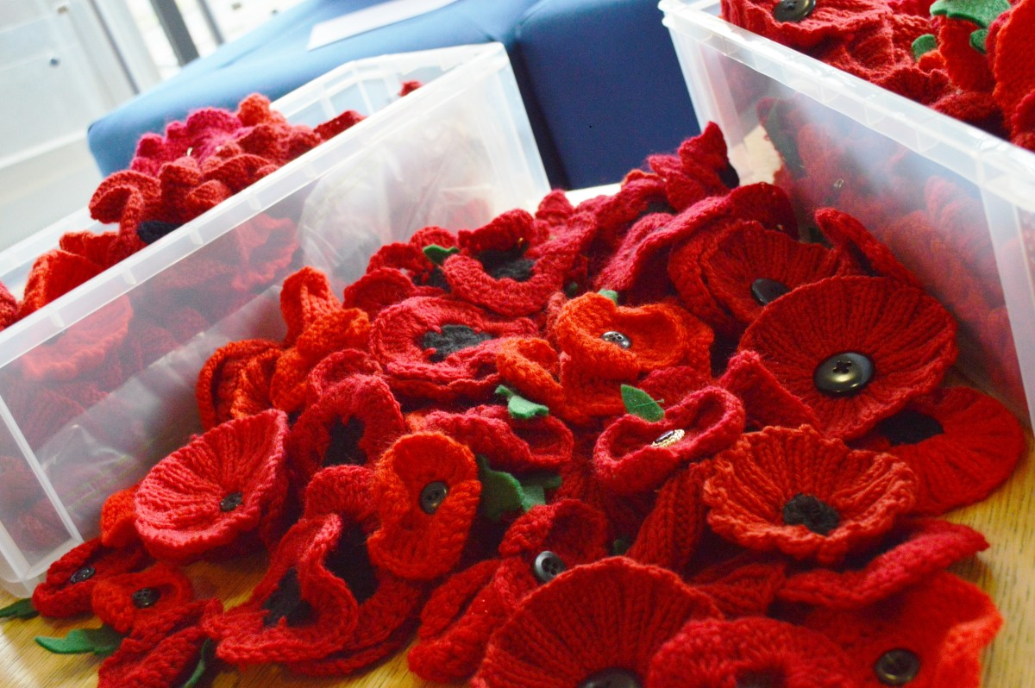
KNITTED POPPIES

For the best finish, knit with a Double Knit (DK yarn) and 4mm needles.

Garter Stitch Pattern – Easy Diameter 3.5cms/4.5 ins
Colour A Red
Colour B Scrap of Black or a black button
Body of Poppy – Using Colour A cast on 152 stitches
Rows 1-4: Knit
Row 5: Knit 1, Sl 1 K2 tog pass sl over, continue to end of row, k 1 remaining stitch (52)
Rows 6-11: Knit
Row 12: Knit 1, Knit 2 stitches together across the row, Knit 1(27 stitches)
Rows 13-16: Knit
Row 17: Knit 1, Knit 2 together across the row, knit 1(13 stitches)
Cut yarn leaving a tail of about 20cm
Thread tail through yarn needle and slip all the remaining live stitches onto the yarn tail and pull tight into a circle. Mattress stitch (or use whatever stitch you normally use) to create an invisible seam. Sew in ends.
Centre of Poppy - Using Colour B, cast on 21 stitches
Cast off 7st, knit 14 to the end of the row. Cast off 14st, cut yarn leaving long tail. Coil into a tight spiral, and stitch together with tail, then sew to centre of poppy. Alternatively use a black or green button with 4 holes.
Ribbed Poppy Pattern – Easy Diameter 12.5cms/5.5ins
Colour A red
Colour B Scrap of black yarn or black button
Body of Poppy – Using Col A Cast on 96
Row 1 –10: K2, P2
Row 11: K 2 tog, (48).
Row 12: K 1, (sk2togpo) rep to last 2st, k2 tog (18)
Row 13: K 1, (K2 tog), rep to last st, k1. (9) Break off yarn with long tail and thread back through remaining sts and pull tight. Join edges with mattress stitch.
Centre of Poppy – Colour B Cast on 21
Cast off 7, k to end.
Cast off remaining 14 , leave a long tail.
Coil into a tight spiral, stitch together with tail, then sew base to the centre of poppy.
Alternatively use a black or green button with 4 holes and sew to centre of poppy.

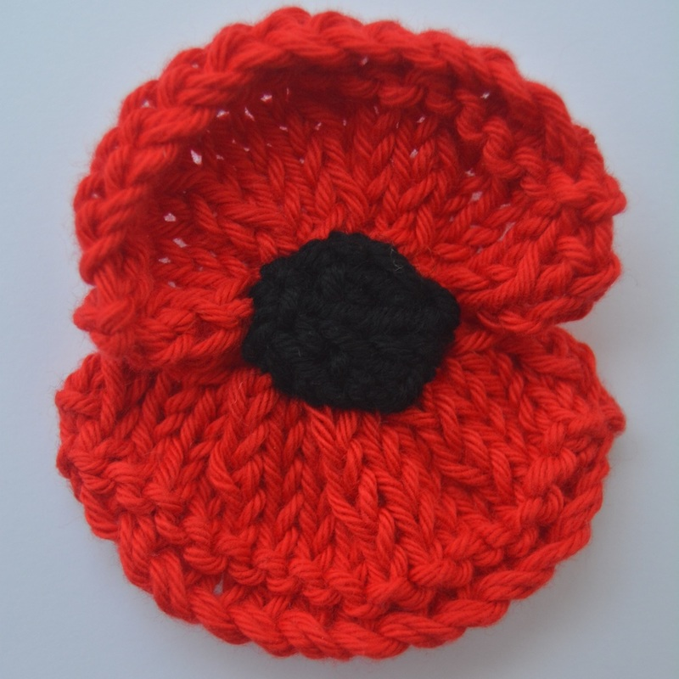
Remembrance Style Poppy – 10 cms/4ins x 9cms/3.5ins
Colour A red yarn
Colour B Scrap of black yarn
Poppy Petals (make 2) – Using Colour A cast on 32 (outer edge of poppy)
Row 1: Kfb, k to last 2 sts, kfb, k1. 34 sts
Row 2: As Row 1 – 36sts
Row 3: As Row 1 - 38 sts
Row 4: Purl.
Row 5: K1, (skpo, k2) rep to last st, k1. 29 sts
Row 6: Purl.
Row 7: K1, (skpo, k1) rep to last 2 sts, skpo, 20 sts
Row 8: (P2tog) rep to end. 10 sts
Cast off. This is the inner edge of the petal.

​Centre - Using Colour B, cast on 2

Cast on 2 sts using black yarn.
Row 1: Kfb. K1 - 3 sts
Row 2: Purl.
Row 3: Kfb rep to last st, k1 - 5 sts
Row 4: Purl.

Row 5: Kfb, rep to last st, k1 - 9sts
Row 6: Purl
Row 7: Kfb, rep to last st, k1 - 17sts
Row 8: Purl
Row 9: Skpo, rep to last 2st, k2 tog, - 8sts
Row 10: Purl
Row 11: Skpo, rep to last 2st, k2tog - 4sts
Row 12: Purl
Row 13: Skpo, k2tog – 2sts
Row 14: K2tog. Cut wool leaving a tail of 4 - 6 ins, thread through final stitch, secure. Thread tail onto a large needle and sew a running stich around the edge of the small square of knitting, pull into a circular shape and secure. Leave tail for attaching later to centre of Poppy. Sew other tail end into back of circle.

Making Up
Overlap the two inner edges of the petals in the centre. Sew in place using tails, along cast off edge only. Take yarn through to back and fasten off. Place black circle on top of the petals right in the centre. Stitch in place around the edge of circle, concealing stitches underneath. Take yarn through to back and fasten off.
Knitting Abbreviations
Kfb knit into the front and back of the stitch, thus making a stitch
Skpo slip one stitch, knit one stitch, pass slipped stitch over
P2tog purl two stitches together, thus decreasing by one stitch
K2tog knit two stitches together, thus decreasing by one stitch
P3tog purl three stitches together, thus decreasing by two stitches
Rep repeat

